STUDENT Joseph Roper

Salford City College | [Company address]

BTEC National Extended Diploma in Creative Media Production

Unit 6: Critical Approaches

Research Techniques

# Research

Research is the gathering of information by studying materials and sources or asking people to retrieve facts, evidence and new conclusions. The reason research is so important to the games industry is because with it they can find out who their target market is meaning they know what age group they should market the game to and what gender they should market the game to as well.

The purpose of research is to learn and gather information, research is important when developing a game as you can see which genres have succeeded and failed in the past. This will inform the developers for example if first person shooter (FPS) games are popular and horror games are not the developers will know not make a horror game and think about making a first-person shooter.

Research allows for a developer to find out who their target market is. The target market is the specific audience for your game or product, so you would tailor your game or product to match the needs of your target market. For example, if your target market is aged from 4 to 6 you would ensure your game wasn’t a horror game or contained realistic guns or violence.

# Types of Research

## Quantitative Research

Quantitative research is the gathering of information usually a lot of it to make a graph or chart to easily represent the data gathered to the researcher or developers this is usually done in the early stages of development to find out what the developers should make. Quantitative research is important as it generalises results in a numerical format and allows the developer to find out what their target market or the public want in a video game through simple questions given to a lot of people. Quantitative questions are usually multiple choice and include tick boxes as shown in the example below. The person answering would tick as many boxes as they like and the information gathered would be recorded. From the chart we can see that he publics favourite genre of games are shooters this tells the developers that if they make a shooter genre of game it will get the biggest fan base and players out of all the other genres on the question.

|  |
| --- |
| What is your favourite genre of game?  (Tick all boxes that apply) |
| Platformer |  |
| Shooter |  |
| Racing |  |
| Rhythm |  |

### Advantages

Firstly, quantitative research is easy and fast to collect as well as analyse because it only takes a minute or two to collect the information and input it into a Microsoft Excel sheet and make a chart.

Secondly, the repeated information and the trusted set of statistics can give confidence to developers when making future plans for a game.

Thirdly, quantitative research can be anonymous which is useful for sensitive topics or shy people as this will give them the confidence to answer and complete the questions honestly.

### Disadvantages

Firstly, quantitative questions don’t give people much choice as if they disagree with the question or don’t like any of the genres for example with my question they can’t fill it in.

Secondly, quantitative research can be costly as you must print out the questions hundreds of times.

Thirdly, as quantitative questions are usually aimed at the public and not the developers target market people may share opinions that don’t apply to the audience creating a potential bias in the study and information.

Finally, quantitative research isn’t the most effective way of getting peoples true opinions leaving holes in the developer’s knowledge of the research.

## Qualitative Research

Qualitative research is the gathering of information from a developer target market through questions that ask for people’s opinions and allow for descriptive answers. Qualitative research is usually collected through focus groups containing the target market. Quantitative questions usually shape the developers target market whereas qualitative questions refine it and find out what their target market really wants in a game. Qualitative research like quantitative is also usually used in the early stages of development as well. Researchers and developers use qualitative research to find out what their potential fan base would like in a video game and what entertains them about a specific genre. Unlike quantitative questions qualitative questions take a longer time to fill out which provides the researcher/developer with more detailed responses. Also answers to qualitative questions cannot be represented as a graph or chart because the questions ask for a person’s opinion and are meant to be read entirely making the process of getting the relevant information out of the answers tedious and long. An example of a qualitative question is the one down below, it looks the same as the quantitative question example but with the added “Why?” section, this is where the person answering would go in-depth about why they love that specific genre of game, because of this added “Why?” section this question would not be given to a large group of people as it would take too much time for the person answering that they might just skip that section and if they don’t that is too much work for the developers/researchers to read all of the answers.

|  |
| --- |
| What is your favourite genre of game? And why?  (Tick all boxes that apply) |
| Platformer |  |
| Shooter |  |
| Racing |  |
| Rhythm |  |
| Why: |

### Advantages

Qualitative questions allow for topics to be explored in more depth and detail than quantitative questions.

Qualitative research is often cheaper than quantitative research as less paper is needed to be printed out and less people are needed through recruitment.

Finally, qualitative research offers flexibility and is more convenient to collect as large groups are not needed to be interviewed at once.

### Disadvantages

As qualitative research is purely based on opinions it is hard to justify whether the people interviewed have the same opinion as others making it harder to get any type of solid statistic to base your actions off when developing a game.

Finally, because qualitative questions take quite a bit of time to fill out it is hard to find people who will fill in the questions making it harder to get any research at all.

# Data Collection Organisations

## BARB

Barb is responsible for delivering the UK’s television audience measurement system. Barb wants to know who is watching, when are they watching, which screen they are watching on and how it got to the screen (i.e. did it come through Facebook a friend?)

The BARB panel consists of over 12,000 people living in homes with BARB meters installed on their TV’s along with BARB software installed on their laptops, phones and tablets. This software allows Barb to track what you are watching, the time you are watching it and who in the household is watching that content. BARB will also spontaneously visit your home for a check-up to see that you are using their software correctly and to get rid of any anomalies such as if the 8 year old of the households data shows the they have been watching crime dramas., they will know this as they have employed people to look at each household viewing data every day to look for these anomalies. If you announce that you are on the panel maybe through social media you will be kicked off “to ensure confidentiality and privacy for those participating” meaning that in order to keep the panel members privacy secure they will break your privacy by looking at your social media accounts to see if you have told anyone that you are on the panel. However they also take audio recorded by the TV meter and BARB software installed on your devices and listen to it to see whether or not you are watching the program that you say yourself are watching. But why does BARB do all this, well according to Marie Oldham in a speech given at Bafta she says this on behalf of BARB: “It’s not for no reason that we were called the hidden persuaders, we are trying to find evidence to help us understand why people do what they do, why people watch what they watch, why people still sit on their sofas in an evening watching content and really use what we know about their behaviour to persuade them to do things, to persuade them to shop in different ways, to go online and behave in different ways, that is our goal”. From this I can see that BARB’s goal is to learn how to persuade people. I think BARB is not needed because we don’t need another company trying to control people to buy products, however of course marketing companies will want and need this information so that they can advertise their products effectively.

<https://www.barb.co.uk/about-us/how-we-do-what-we-do/>

<https://vimeo.com/246942143?from=outro-embed>

## RAJAR

RAJAR stands for Radio Joint Audience Research and is another data collection company like BARB them get data from radio audiences in the UK, RAJAR was set up in 1992 and is owned by both the BBC and the Radio centre on behalf of the commercial sector. RAJAR is a non-profit organization collecting information from an annual sample of approximately 100, 00 respondents aged 15+. The participants are asked to keep a diary recording their radio listening for a week and then give it to RAJAR for them to analyse. With this information RAJAR find new ways to advertise to their viewers with their “continuous programme of innovation and development to meet its market’s needs.” I also think that RAJAR is not needed as they are trying to do the same things as BARB.

<https://www.rajar.co.uk/content.php?page=about_key_facts>

## OFCOM

OFCOM’s duty is to regulate and monitor the TV, radio and postal services making sure they do their job and provide affordable services and products. OFCOM do this as they have been ordered by Parliament to provide advice and information about these services to the public through their website and call centre. I believe OFCOM is needed so that the public is not taken advantage of.

<https://www.ofcom.org.uk/about-ofcom/what-is-ofcom>

## EEDAR

EEDAR is an organization focused entirely on collecting data/information revolved around the gaming industry and turning it into reports such as statistics providing which brand of gaming mice are the most popular in the public's eye which be Logitech as you can see from the pie chart.

[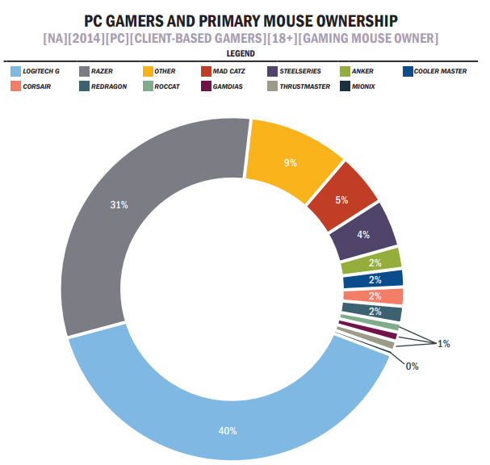](http://denintelligenteinvestor.dk/wp-content/uploads/2015/05/EEDAR_%E2%80%93_PC_Peripheral_Market_2015.pdf)

EEDAR collect this data to sell to people who want it, and will occasionally release the data found in say 2015 later on in 2017 to the public when it is no longer useful. Their customers will most likely be reporters who want to write a piece about the gaming industry and the need statistics to back their point up or gaming brands that want to know what the public thinks about their products and to find out how their competition is doing. They could also use the information to see how the market is changing and how their business should adapt to the new market to make more profit for example in 2017 EEDAR probably released a pdf providing information on how more gamers are buying products that have flashy lights (RGD), so if a company read this they could add lights onto their products and most likely appeal to more people meaning more sales. EEDAR are currently working on a new project called game pulse that allows users to see the data of games, such as how many people played that day or week. A company could use this to their benefit as they can see if their game is slowly declining in players and if so they could release more content to the game to get their previous fans to start playing again. I believe EEDAR is needed as they provide useful information for the games industry.

<https://www.eedar.com/gamepulse>

<https://www.youtube.com/watch?v=irUxIXgji9c>

# Methods of Research

## Primary Research

Primary research is research that has never been carried out before and involves gathering information for the developers/researchers. Primary research should meet the developer’s specific needs so that the information collected is unique to their investigation. Primary research does not have to be done by the researcher/developer as you can also hire a firm to carry the research out although this saves time and work for the developer it can also be costly, and the developer might not get the information he wanted back from the firm’s research. A perfect example of primary research is from the company Nintendo as they wanted to add a new character to their fighting game Super Smash Bros. for Nintendo 3DS and Wii U, but they didn’t know which character out of their many games to add so they asked their fan base and got them to pick out one character they wanted added to the game of a list of characters on their website. This is primary research as the information was not previously out there on the internet, so they had to carry out the research themselves with the help of their fan base the perfect target audience.

[](https://www.youtube.com/watch?v=DNXOVQibYYA)

### Advantages

The advantages of using primary research are that you can tailor the information specifically around your target market without having to use secondary research and read through a lot of useless information to your investigation. Also, as it is the developers/researchers specific research it can be changed to adapt with new information such as if you were going to advertise your game around the male demographic and you do some primary research and find out that your game has a big fan base for the female demographic you can change the investigation to find out what woman would like in a game too.

### Disadvantages

Firstly, as I’ve discussed previously primary research takes too long and is a very tedious task also in some cases the researcher/developer could come up blanc with the investigation and not learn anything new. Secondly, primary research can be very expensive depending on how big the task is, how many people are going to be interviewed and finally how long the investigation will continue for.

## Focus Groups

Focus groups are where you get a room of people usually people in your target market and ask them questions about your product or game.

### Advantages

* You get to have a discussion with your target market and you can find out a lot of new information.

### Disadvantages:

* They can be hard and take time to set up.
* Sometimes you could just not get any new information at all.
* You could get the wrong people who don’t even play games.

## Questionnaires

These are sheets of paper with a bunch of questions on them, they can contain quantitative and qualitative questions which the public or your target market are expected to complete.

### Advantages:

* They are easy and fast to make
* It is a way of achieving quick answers and research.

### Disadvantages:

* The equipment for the questionnaires such as paper and printing it out can be costly
* You could get false research as some may just tick every box on the right to get it over with, so they can carry on with their day. Also, you will mainly be ignored by people unless they get a reward for finishing the questionnaire like with Google they have a Google Rewards app where if you finish questionnaires you get money for the app store.

## Interviews

Interviews are when the developer/researcher talks one to one with someone or a small group and asks them questions about their product/game.

### Advantages:

* Interviews allow for in-depth responses from the participants.
* The interview can be recorded to be played through later to get the information.
* If the participant doesn’t understand a question they can ask the interviewer to clarify it making it, so the participant gives a more specific response to a question.

### Disadvantages:

* Interviews can take time, effort and money to set up things that researchers/developers cannot afford to waste as it is always a risk because the interviewer could just get no information from the participants.

# Psychographics

Psychographics defines a person by their personality this may be through their interests, the activities they involve themselves in and the opinions they have about things. Using Psychographics is a better way to advertise your product than using demographics as if I’m trying to sell a classical music CD rather than just saying people who listen to classical music are usually aged 35 – 60and advertise to that age group I will look for people who are interested in the music maybe share the same activities as other classical music fans such as playing the piano. Meaning that I will advertise my CD in a Classical music magazine or a classical music radio station and maybe a shop that sells piano’s.

# Demographics

Whereas psychographics tries to find a more niece group to advertise to demographics is all about trying to group their audience together to get more quantitative data. Basic demographic grouping can be age, gender, class, nationality and ethnicity. A magazine that defines their audience with demographics is HEAT, as you can see from the image I can work out that HEAT’s audience is most likely Middle aged woman as a typical HEAT reader according to these statistics is 30, female, married and most likely has kids on the way or already has them. So if I was to sell this magazine I would put it in the shopfront of a big supermarket like Asda so they would buy it on their weekly shop.

[](https://www.youtube.com/watch?v=qZUUjq4ZEfY) [](https://www.youtube.com/watch?v=qZUUjq4ZEfY)

# Audience Profiling

I am going to try and guess the; age, gender, regional identity, socio economic status, psychographics and gaming preferences of the fans of the game franchise Super Smash Brothers just off of the marketing for the game. For the age of their fans/players of the game I will assume its 12 - 25 considering that it is a fighting game it should be for an older audience such as 15+ however there is no blood in the game and it uses Nintendo’s characters such as Mario and Pikachu so it can be played by children as it only contains cartoon violence.

For the gender of the players I believe it will most likely be male as it’s a fighting game and most of the characters in the game are male as well as the people in the adverts playing the game are usually male. However I believe females also play it due to the character roster having pink characters like princess peach and Kirby. Also because all the adverts try to include a 1:2 or 2:6 ratio of female to males so Nintendo is clearly trying to market more to males but also somewhat of the other gender too.

[](https://www.youtube.com/watch?v=j_WDbgOku9w)

[](https://www.youtube.com/watch?v=j_WDbgOku9w)

I believe most of the players for this game rather live in Japan or English speaking countries as all of the marketing is rather in English or Japanese meaning that you’ll only find out about the game if you're rather a massive fan of Nintendo or you see and advert in one of those countries.

I think the socio economic status of the players is middle class to upper class as to play the game which was released at the price of £40 you also have to own the Wii U console which is roughly £300 brand new, meaning people without money won’t want to spend money on a console with only a few good games and which doesn’t really receive 3rd party games.

I believe people who play Super Smash Brothers Wii U will also like other fighting games due to the genre of the game or other Nintendo games as they play Smash because their favourite characters are in the game.

As super smash brothers is meant to be a family game it should cover all of the gaming psychographics to appeal to the whole “family” which I think it does as it obvious covers action and achievement because it is a fighting game meaning the goal is to win (Achievement) by beating up your opponent through punches kicks and explosions (Action). It also covers social as you can play against your friends and mastery as it can be a competitive game by going to competitions to win money which you will need to practice a lot for. Finally it covers creativity as the game is about getting characters from different games and finding out who will win in a fight and lastly immersion as you get to play as someone else and as in Super Smash Brothers Brawl there was a really good story mode.[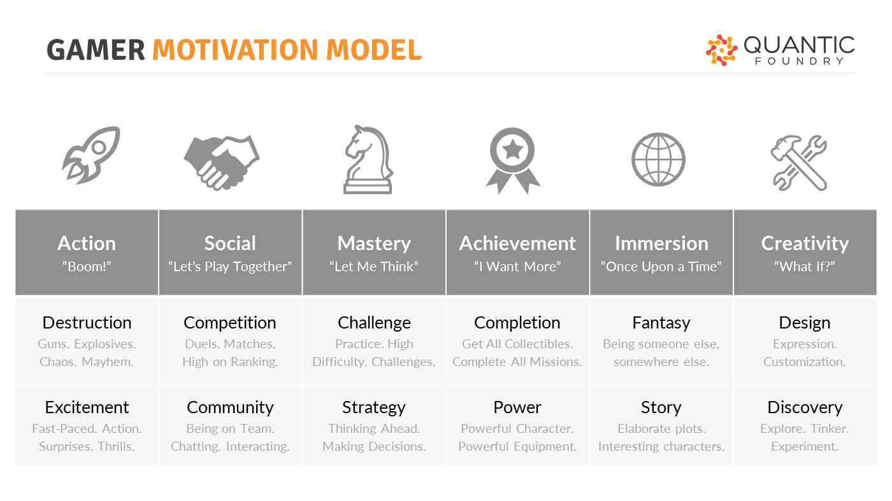](https://quanticfoundry.com/2017/08/29/just-important-female-protagonists/)

As you can see audience profiling can be incredibly useful for developers because you can find out your target audiences; age, gender, where they live, the language they speak, their economic status and psychographics. With this information you can find out the exact type of people you should market too and where you should market your game. For example if my game is like World of Warcraft and I know most of the audience for that game is 35 year old males, overweight and in English speaking I can work out that I should advertise my game in America and England because they are English speaking countries and contain a high amount of obese and overweight people with the popularity of fast food restaurants, I should also advertise my game on the internet because overweight people spend more time on the internet usually than going outside. I would put my advert on YouTube and select it so it is more likely to play the game on World of Warcraft gaming videos. Also because my target audience is for adult males I will have my adverts contain violence to attract them to play the game. Now this may seem really mean and seem like I’m almost invading someone’s privacy but this is what massive gaming companies marketing teams think of and do, because it works.